Insert your logo



Risk Management Framework for Small to Medium Businesses

[insert date]
Table of Contents

IMPORTANT NOTE: 1

POLICY STATEMENT SUMMARY 2

1 INTRODUCTION 3

2 SCOPE 3

3 RISK ROLES AND RESPONSIBILITIES 3

4 RISK MANAGEMENT FRAMEWORK 5

4.1 RISK APPETITE STATEMENT 5

4.3 RISK MANAGEMENT PROCESS 6

4.3.1 COMMUNICATION AND CONSULTATION 6

4.3.2 SCOPE, CONTENT AND CRITERIA 6

4.3.3 RISK ASSESSMENT 7

4.3.4 RISK TREATMENT 9

4.3.5 MONITORING AND REVIEW 9

4.3.6 RECORDING AND REPORTING 9

Appendix A – Summary of Key Risk Management Activities 11

Appendix B - Likelihood Criteria 13

Appendix C – Consequence Criteria 14

Appendix D – Risk Rating Matrix 17

Appendix E – Risk Register Template 18

Appendix F – Controls Effectiveness Rating 19

Appendix H – Risk Escalation Criteria 20

Appendix I – Risk Escalation Process 21

Appendix J – Risk Treatment Plan 22

Appendix L – Risk Management Glossary 25

IMPORTANT NOTE:
This template is designed to support your organisation to develop a risk management framework and to help to ensure risk is managed consistently and effectively.
This document is a template and should be modified and other aspects added as required to suit your organisation’s structure and approach to risk management and the context of your business and operating environment. Seek advice from a risk consultant for further information.
After designing the framework, your organisation should develop a plan to implement it across the organisation. At least annually, you should review the adequacy of the framework and improve it to ensure it continues to meet the needs of the organisation and can respond to your changing risk environment.
Contact us at info@ansvarrisk.com.au for any additional Information or support.

POLICY STATEMENT SUMMARY

(See [insert organisations name]’s Risk Management Policy)

[insert organisations name]’s is committed to an organisation-wide Risk Management Framework (the framework) to support good governance, sound decision making and improved performance.

[Insert organisations name]’s will implement and maintain a risk management framework that is aligned with better practice guidelines and standards, in particular the Australian and New Zealand Standard AS/NZS ISO 31000:2018 – Risk Management Guidelines

The framework will support a positive risk culture; where every person thinks about risk and manages risk as part of their job. It will compliment and support other frameworks of the organisation and be integrated in all aspects of planning, project management, decision-making and day to day processes.

This framework defines the governance, resources and processes for risk management at [insert organisations name]

It will be reviewed annually by Board / CEO to ensure it meets its purpose, remains current. The effectiveness and capability of the framework (risk maturity) will be monitored and continuously improved.

Chief Executive: __________________________________ Date ____/____/____

Board Chair: __________________________________ Date ____/____/____

1 INTRODUCTION
Risk management is Important for good governance and business success. It helps to achieve objectives, improve performance, prevent harm and assist us to become more resilient.
The Risk Management Framework provides a consistent approach to the management and communication of risk and sets out guidance and expectations with responsibilities and decision making.
The principles underpinning [insert organisations name]’s risk management framework include:
- Clear accountability and responsibilities for risk management across the organisation
- Ensuring risks are confined to an acceptable level within the [Insert organisation name] risk appetite
- A risk culture that supports [insert organisations name] values, decision making and behaviours.
- Effective risk management systems and processes
- Organisational Resilience program that responds and adapts to any interruptions to [insert organisations name]

2 SCOPE
This policy relates to all business units and activities undertaken by [insert organisations name]. It is the responsibility of all staff, contractors and volunteers to manage risk as part of their roles as outlined by this policy. The Executive Team is responsible for the implementation of this framework.

3 RISK ROLES AND RESPONSIBILITIES
[Adapt to suit your organisations structure]

ROLE | RISK MANAGEMENT ACCOUNTABILITIES AND RESPONSIBILITIES
BOARD | The board is ACCOUNTABLE for [select relevant items]  - Authorising and overseeing the framework.  - Setting expectations with risk culture.  - Contributing to identifying strategic risks and high operational risks.  - Analysing risk information and setting oversight responsibilities of the Risk Committee.  - Monitoring the strategic decisions of the board using risk information.  - Approving risk appetite and risk policies.  - Reviewing the framework at least annually and ensuring improvements are implemented.
RISK COMMITTEE | Responsible for: [select relevant items]  - Oversight of the risk management framework and risk culture.  - Advising board on emerging risks and variation in existing risks.  - Monitoring compliance with risk appetite.  - Reviewing risk information, including trends and themes from incidents and events to report to Board.  - Directing internal audit program and monitoring corrective actions.  - Ensuring relevant information from other subcommittees is provided to inform the progress of key strategic risks.
CEO | CEO is responsible for organisational leadership of the risk framework: [select relevant items]  - Fosters a positive risk-aware culture across the organisation  - Ensures risk framework is integrated into strategic, operational and project management  - Establishes risk reporting and communication framework and monitors key risk information  - Oversees communication to Risk Committee and Board on risk management and compliance with risk appetite.  - Ensures staff understand their risk management role and incorporates this in performance reviews  - Provides resources to build risk capabilities across the organisation.  - Establishes strategic risk profile and ensures it is reviewed in accordance with board expectations  - Support the internal audit program and ensure all corrective actions are addressed.  - Supports the review of the risk management framework, at least annually.
EXECUTIVE TEAM | Oversee the implementation of risk management across the organisation and identify opportunities for improvement. [select relevant items]  - Integrate risk management in strategic and operational planning.  - Ensure risk framework is integrated with regulatory and organisational frameworks.  - Monitor and review risks and risk-related information (incidents, complaints, serious events) and escalate as required.  - Ensure staff are orientated to the risk framework and education programs are in place to support risk capabilities.  - Identify new and emerging risks and the relevant risk owners.  - Provide resources for staff to manage risks.  - Monitor and report to CEO on risk culture.
RISK MANAGER | Coordinate the implementation and ongoing development of risk management across the organisation. [select relevant items]  - Support staff to understand their responsibilities with respect to risk management and are provide training, education and assistance.  - Support the executive with the management of the strategic risk register and reporting.  - Support activities and priorities of the internal audit function.  - Monitor and coordinate reviews and continuous improvement of the framework and risk culture.  - Monitor compliance with regulatory obligations.
RISK OWNERS | Ensure: [select relevant items]  - Risks are identified, assessed, managed and monitored.  - Risks are clearly articulated in risk statements.  - Appropriate level of risk tolerance is determined.
RISK TREATMENT OWNERS | Accountable for monitoring and reporting implementation progress of the treatment plan.
STAFF/ VOLUNTEERS/ CONTRACTORS | [select relevant items]  - Promote and support a positive risk culture across the organisation.  - Adhere to risk management policy and framework  - Participate in the identification and management of risks relevant to roles and responsibilities  - Report new or emerging risks to line manager or relevant executive.  - Report and manage incidents, complaints and hazards in a timely way and report serious events to line manager or relevant executive.

4 RISK MANAGEMENT FRAMEWORK

Risk Appetite Statement
Risk Culture
Risk
Categories
Risk
Process
Roles and Responsibilities
Board and Board Committees
Oversight
CEO and Executive Team
Accountability
Risk Manager
Manage Risks and develop risk treatments and controls
Staff/ Volunteers/ Contractors
Participate in the identification and management of risks

4.1 RISK APPETITE STATEMENT
The Risk Appetite Statement sets out the amount and type of risks the [Insert organisation name] is able and willing to accept in order to achieve our strategic objectives. The [insert organisations name]’s strategy and strategic risks forms the reference point for the organisation's risk appetite. The risk appetite should be reviewed any time there are changes to the organisation's strategy.

4.2 RISK CULTURE
Risk Culture refers to the behaviours that lead to how everyone thinks about and manages risk. It is part of the overall culture of our organisation.
CEO (and Board) is responsible for setting the “tone at the top” and play a key role in influencing a role modelling a positive risk culture.
Developing a positive risk culture is important as it will:
- Create the tone and expectations for risk management.
- Ensure behaviours reflect expectations in line with our values
- Underpin risk-based decision making
- Ensure everyone plays a role in risk management.

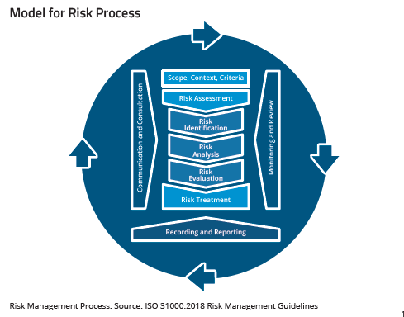
4.3 RISK MANAGEMENT PROCESS
The Risk Management process has six key stages:
- Communication and consultation - with internal and external stakeholders
- Scope, context and criteria - the boundaries
- Risk assessment – risk identification, risk analysis, analyse and risk evaluation
- Risk treatment – implement and assess actions to address risk
- Monitoring and review – risk reviews and audit
- Recording and reporting – what needs to be documented and reported

4.3.1 COMMUNICATION AND CONSULTATION
[insert organisations name] communicates with staff, contractors, volunteers, business unit, insurance brokers and other key stakeholders with involved in risk management and includes the following elements:

INTERNAL COMMUNICATION AND CONSULTATION
- Communication and consultation internally builds a risk aware workforce and supports accountability and ownership of risk. This includes:
- Key components of the Risk Management Framework and any changes;
- Relevant information for risk management is available to staff at all levels;
- Processes are in place for consultation with internal stakeholders.

EXTERNAL COMMUNICATION AND CONSULTATION
Communication and consultation with external stakeholders supports effective exchange of risk information and helps build confidence in the organisation's management. This includes:
- External reporting to meet regulatory, governance and compliance requirements;
- Communication with clients and stakeholders in the event of major or incident a crisis; and
- Communication with stakeholders and third-parties on the management of risk.
See Risk Management Communication Plan shown in Appendix K.

4.3.2 SCOPE, CONTENT AND CRITERIA
Establishing the scope context and criteria defines the basic parameters for managing risks. This includes considering the external and internal operating environments, community expectations, key stakeholders, Insurance coverage and risk appetite.
Important considerations when determining context include (The organisation context should be modified to suit your organisation's objectives):

EXTERNAL ENVIRONMENT | Social factors, community expectations, demographics, networks and dependencies, market trends, emerging risks.
STAKEHOLDERS | Insurers, service providers, staff and volunteers, residents, clients, regulators.
INTERNAL ENVIRONMENT | Objectives, culture, vision, mission and values, strategy’ governance organisational structures, systems, processes, standards, key performance indicators and other drivers.
APPETITE FOR RISK | What risks do we want to take and how much?

4.3.3 RISK ASSESSMENT
The risk assessment process includes identifying, analysing, evaluating and treating the risk and is documented in [insert organisations name] Risk Management System. Risks are always assessed against objectives. Strategic, business and /or project plans must be developed to support the risk assessment.

RISK IDENTIFICATION
Risk identification is the process of identifying, recognising and recording the organisations risks. The purpose of risk identification is to identify what might happen or situations that might exist that may affect the achievement of the organisation objectives.
It involves deliberately stopping to think about:
- What could occur – the “something” that could happen to consider the potential impact
- Why it would occur – the causative and contributing factors to help determine what controls are required
- How could it manifest and impact the organisation – to inform what decision is required

A Risk Description is broken into 3 elements

The key questions when identifying risks are:
What can happen?
Where can it happen?
When can it happen?
Why can it happen?
How can it happen?
What is the impact?
Who is responsible for managing the risk?

Types of risks

STRATEGIC RISKS | These risks have the potential to impact strategic plan objectives or significant aspects of the business.  Strategic risks are discussed at [insert times] Executive and Risk Committee meetings.
OPERATIONAL RISK | These risks could impact [insert organisations name] business operations and are managed by the respective service leader.
PROJECT RISK | These risks could affect the achievement of a project’s objectives. Of note, project risks are not ongoing risks and should end at the finalisation of the project.
EMERGING RISK | Emerging risks are developing risks that cannot yet be fully assessed, but in the future could affect [insert organisations name] ability to manage the business and deliver our plans. Emerging risks can be internal or external

RISK ANALYSIS
Risk analysis assists to:
- Identify effects on the organisation of the risk;
- Assess current controls, their effectiveness and determine gaps; and
- Determine the severity or level of risk (risk rating) to objectives.
- Assess and strengthen controls. Controls are policies, procedures, plans, processes and systems that have been designed and implemented in response to risks/issues that have or may occur. Identified risks may not be new or unique and the organisation may have controls already in place to manage them

Controls typically fit into three distinct types:
- Preventative Controls - aimed at preventing the risk occurring in the first place. They include policies, procedures, plans processes and systems;
- Detective Controls - used to identify when a risk has become an issue/incident. They include audits, reviews, etc.; and
- Mitigating Controls - aimed at reducing the consequences that comes from the issue/incident. They may include Business Continuity and Disaster Recovery Plans for example.

Steps for analysing risks.
- What is currently in place to manage the risk (current controls)
- How effective are these measures (use controls effectiveness criteria to assist)?
- What Is the likelihood of the risk occurring (use likelihood criteria)?
- What are the potential consequences should the risk occur? (use consequences criteria)
- Based on the combination of likelihood and consequences what Is the level of risk? (use risk rating matrix)

RISK EVALUATION
Based on the risk analysis, the next step in the process is to determine which risks require further action and the priority for implementing the response.
Risk evaluation assists to:
- Escalate risk information to the necessary reporting levels;
- Prioritise risks;
- Identify options and choose required actions and
- Identify resources required.
[insert organisations name] will use the Risk Rating shown in Appendix E.

RISK ESCALATION
The Risk Escalation process for the [insert organisations name] is referred to at 4.3.6 and an example map provided in Appendix H.

4.3.4 RISK TREATMENT
Risk treatment involves:
- Identifying options for controlling the risk and evaluating these options.
- Designing and implementing a treatment plan (if necessary).

All HIGH and EXTREME risks should be reported to the CEO and have a Risk Treatment Plan developed.
The risk response falls into the following options:
- avoiding the risk by deciding not to start or continue with the activity that gives rise to the risk;
- taking or increasing the risk to pursue an opportunity;
- removing the risk source;
- changing the likelihood;
- changing the consequences;
- sharing the risk with another party or parties (including insurers); and
- retaining the risk by informed decision.

The information provided in risk treatment plans should include:
- the reasons for selection of treatment options, including expected benefits;
- those accountable for approving and responsible for implementing the plan;
- Risk owner
- Proposed actions
- Resource requirements
- The order in which actions / tasks should be completed
- Monitoring and communication plan
- Timeframe for completing deliverables

4.3.5 MONITORING AND REVIEW
Risks will be continuously monitored and reviewed; and the effectiveness of the controls in place and of the risk treatment plans will be assessed to ensure changing circumstances do not alter risk priorities.

Feedback on the effectiveness of the Risk Management Policy and Framework will be obtained from the risk reporting process, internal audits and other available information.

Risks and controls will be monitored and tested regularly through the internal audit and continuous improvement programs.

4.3.6 RECORDING AND REPORTING
Risk reporting is an important way of communicating risk information throughout [insert organisations name]. Risks should be logged and monitored using a "Risk Register".

[insert organisations name] has the following reporting and reporting structures:
- Strategic and significant service area risks that affect the organisation as a whole will be reported to the Board [insert time frame].
- The Board Sub Committee will establish a reporting schedule for risks and treatment plans.
- Risks will be captured in the organisational risk register.
- Managers will define risk reporting timeframes and requirements for their areas of responsibility. Risk reporting at the business area level should be integrated into existing management reporting arrangements.
- analysis of incidents, near misses and hazards will be reported to [insert department or committee name] for identification of any risks.

The table below summarises the risk reporting requirements at [insert organisations name] (risk reporting should be modified to suit your organisations objectives):

REPORT | FREQUENCY | AUDIENCE
RISK TREATMENT ACTION STATUS REPORT | Choose Frequency | Insert Audience
INCIDENT REPORTS | Choose Frequency | Insert Audience
STRATEGIC RISK REPORT | Choose Frequency | Insert Audience
OPERATIONAL RISK REPORT | Choose Frequency | Insert Audience
RISK FRAMEWORK STRATEGY REVIEW | Choose Frequency | Insert Audience
INTERNAL AUDIT REPORT | Choose Frequency | Insert Audience Committee

Risk Owners will monitor the currency and status of the risks allocated to them and report this plan. Risks are to be formally monitored and reviewed/reported on by the Risk Owner in accordance with the table below.

Risk level | REPORTING Frequency
Extreme | Choose Frequency
High | Choose Frequency
Medium | Choose Frequency
Low | Choose Frequency

Appendices

Appendix A – Summary of Key Risk Management Activities
(Your risk management activities should be modified to suit your organisations)

ACTION | DESCRIPTION | RESPONSIBILITY | WHEN
Review RM Policy | Review the effectiveness of [insert organisations name]’s Risk Management Policy
Review RM Framework | Review the effectiveness of [insert organisations name]’s Risk Management Framework
Review Risk Register | Review risks and controls contained in the risk register and identify new or emerging risks
Include Risk Treatment Plans in Operational Plan | Ensure that actions required by Risk Treatment Plans are incorporated into the Operational Plan
Implement Risk Treatment Plans | Implement actions contained in risk treatment plans
Risk Assessments for Major Projects / Initiatives | Conduct risk assessments as required for major new or altered activities, processes or events
Risk Status Report | Identify and review, by exception, any risk issues arising from the risk register review and the current status of key risks, incidents and other relevant issues
Operational Plan | Identify key risks that may impact on objectives as well as strategies and controls in place (or proposed) to manage those risks
Training | Ensure risk owners and other staff are aware of the risk management process and their obligations
Staff Performance Review | Ensure risk management performance of managers is assessed on a regular basis
Communication | Ensure staff are aware of relevant risk  management issues and have access to risk management tools
Insurance Review | Assess insurance covers and requirements with Insurance Broker. Use risk profile to assist discussions

Appendix B - Likelihood Criteria
NOTE: THESE ARE EXAMPLES ONLY. RISK LIKELIHOOD CRITERIA SHOULD BE DEVELOPED FOR YOUR ORGANISATION CURRENT AND FUTURE CIRCUMSTANCES.

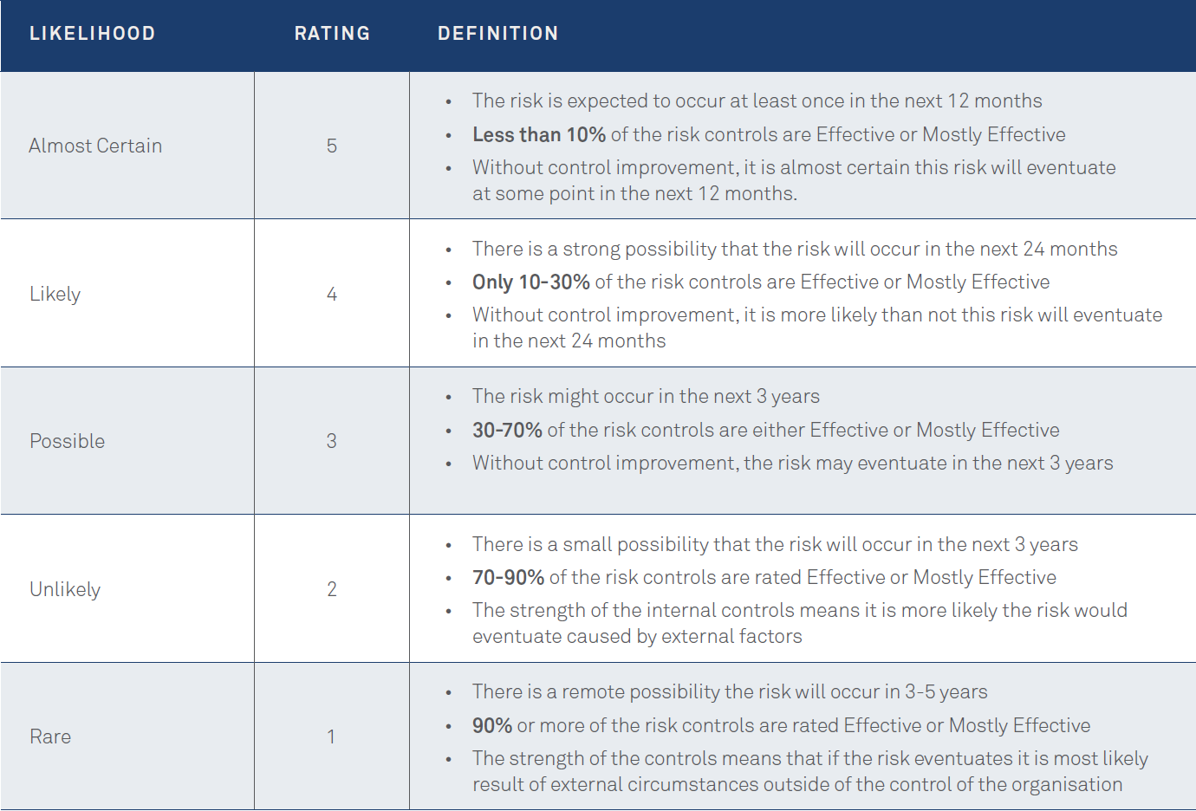

Appendix C – Consequence Criteria
NOTE: THESE ARE EXAMPLES ONLY. RISK CONSEQUENCE CRITERIA SHOULD BE DEVELOPED FOR YOUR ORGANISATION CURRENT AND FUTURE CIRCUMSTANCES.

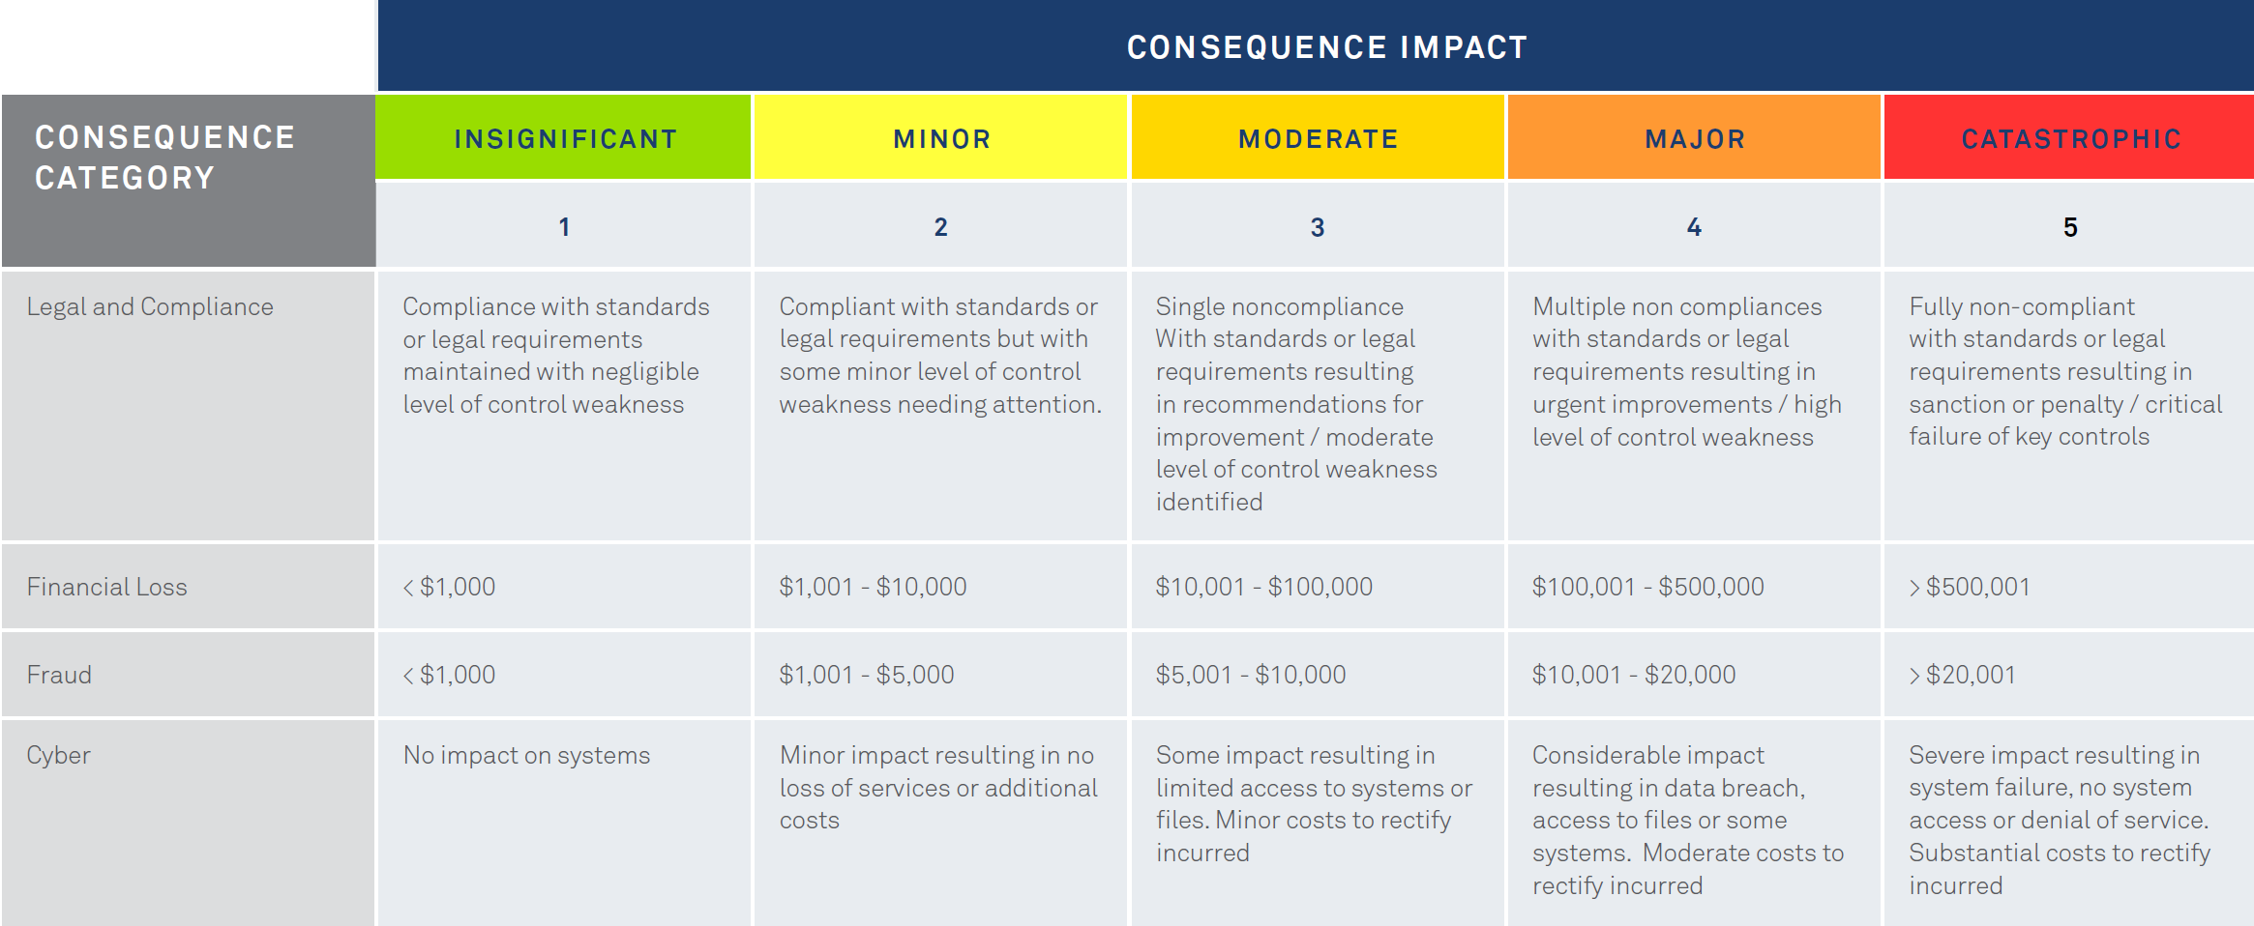

(continued)
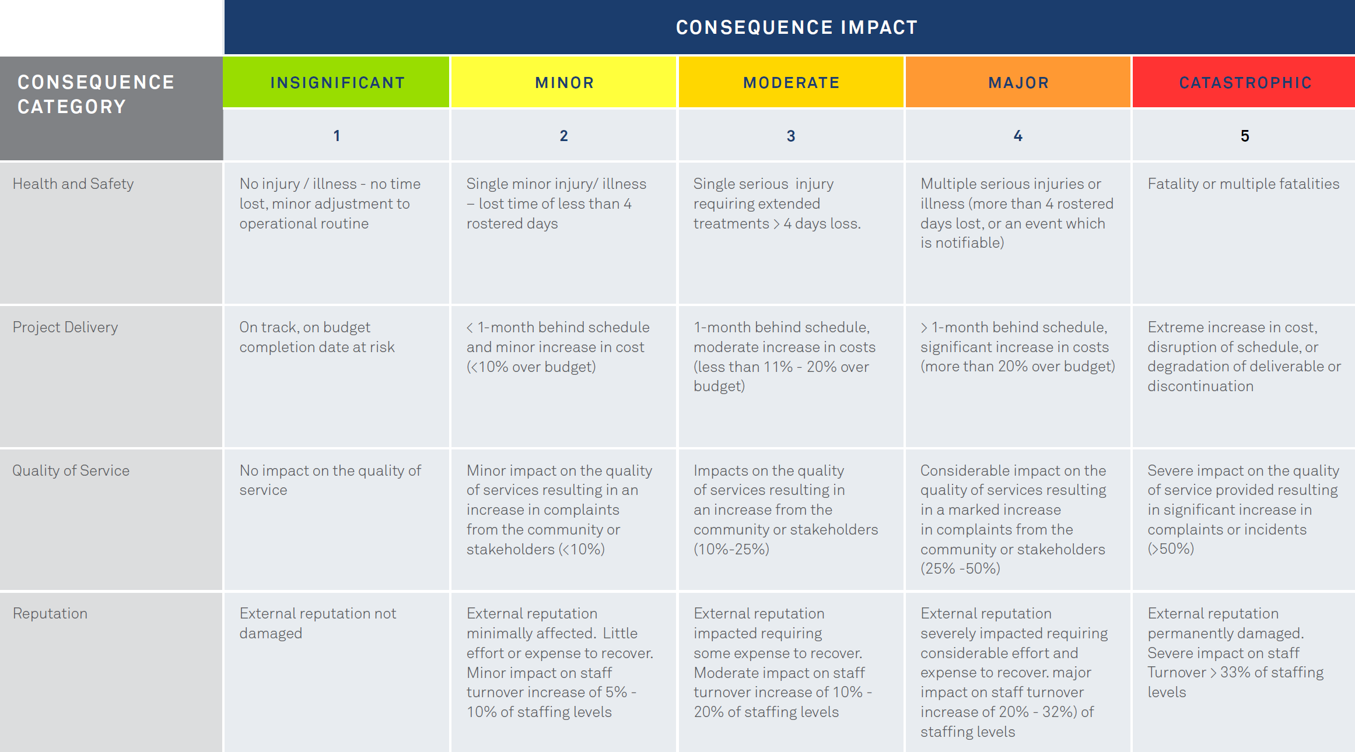

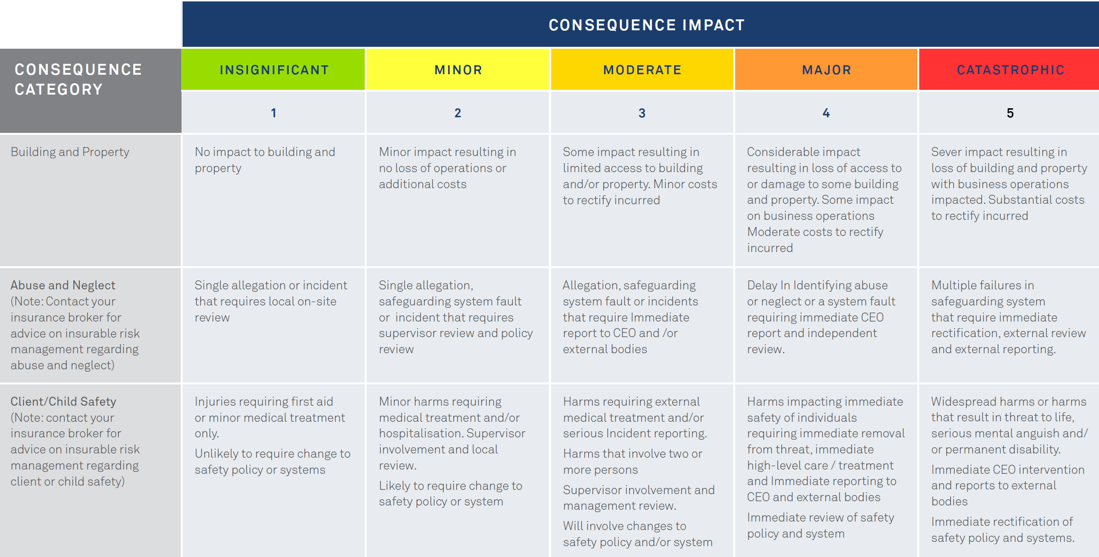

Appendix D – Risk Rating Matrix
NOTE: THESE ARE EXAMPLES ONLY. RISK RATING MATRIX SHOULD BE DEVELOPED FOR YOUR ORGANISATION CURRENT AND FUTURE CIRCUMSTANCES.

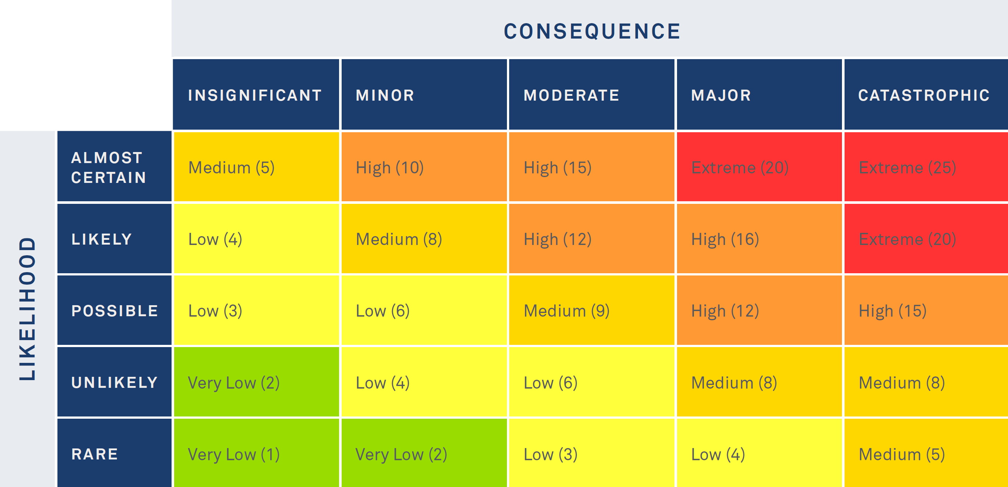

Appendix E – Risk Register Template
NOTE: THESE ARE EXAMPLES ONLY. RISK REGISTER TEMPLATE SHOULD BE DEVELOPED FOR YOUR ORGANISATION CURRENT AND FUTURE CIRCUMSTANCES.

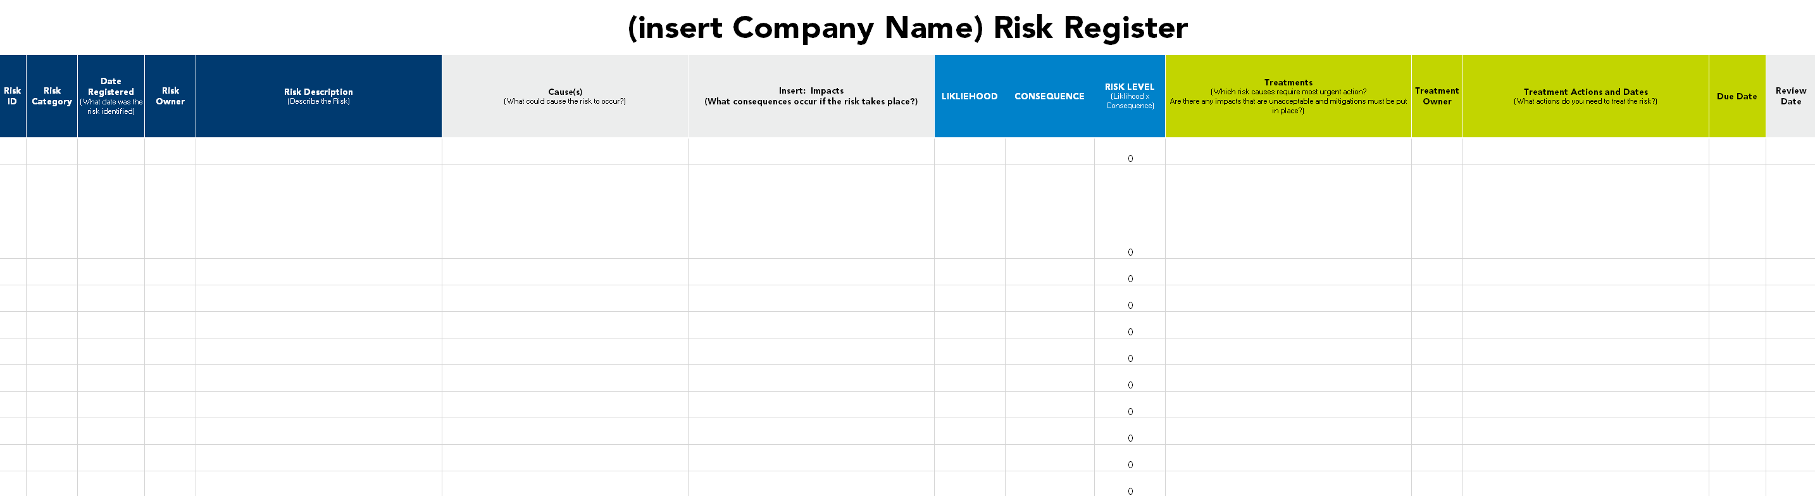

Appendix F – Controls Effectiveness Rating
NOTE: THESE ARE EXAMPLES ONLY. CONTROL EFFECTIVENESS RATING SHOULD BE DEVELOPED FOR YOUR ORGANISATION CURRENT AND FUTURE CIRCUMSTANCES.

RATING | Criteria
EFFECTIVE | - The controls design is effective with no major control improvements required.  - Controls are effectively performed to design specification.
MOSTLY EFFECTIVE | - Controls design is satisfactory; however minor improvements have been identified.  - Controls are performing low levels for the design specification and need improvement.
PARTIALLY EFFECTIVE | - Controls design is satisfactory; however major improvements have been identified.  - Controls are performing below design specification and need major improvement.
NOT EFFECTIVE | - The controls have not been designed.  - The control designed is not performed and the control system is largely ineffective.

Appendix H – Risk Escalation Criteria
NOTE: THESE ARE EXAMPLES ONLY. RISK ESCALATION CRITERIA SHOULD BE DEVELOPED FOR YOUR ORGANISATION CURRENT AND FUTURE CIRCUMSTANCES.

Level of Risk | Action Required
EXTREME | Immediate action required – report to Risk Manager, CEO and in turn, Risk Committee Chair. Risk treatment plan to be led by the Executive team
HIGH | Requires immediate notification to line manager and Risk Manager. Action plan must be developed as soon as possible and no later than 2 weeks.
MEDIUM | Requires immediate notification to Risk Manager and line manager and the development of an action plan.
LOW | Requires immediate notification to line manager and the development of an action plan.

Appendix I – Risk Escalation Process
Does the risk require further treatment?
No action necessary; maintain existing controls
Determine risk treatments and actions to remediate
After treatments are applied, will the risk be within the nominated Risk Appetite?
Record Risk in Risk Register and undertake treatments.
Record Risk in Risk Register. Escalate to relevant level
Escalate to the appropriate line manager?
Will further treatments be undertaken?
Identify additional risk treatment actions and/or resourcing.
Advise Risk Acceptance to the appropriate person(s)
Yes
No
No
Yes
Is there any immediate
danger?
Undertake immediate stabilising action(s) to remediate.
No action necessary – manage risk as normal.
No
Yes
Risk Identified and Evaluated

Appendix J – Risk Treatment Plan

RISK | Possible Treatment Options | Preferred Options | Accept / Reject Option | Who will implement option/s? | By When? | How will the risk and treatment option be monitoried?

Appendix K – Risk Management Communication Strategy Template

Stakeholder Communications Plan
Stakeholder Name | Stakeholder Type | Contact Details | Delivery Method | Spokeperson
 | Board
 | Risk Committee
 | Executive Team
 | Regulators
 | Risk Owners
 | Risk Treatment Owners
 | Employees/Contractors/ Volunteers
 | Clients
 | Insurer/Broker
 | Other

Key Message Plan
Stakeholder Group | Messages | Delivery method | By who and When

Appendix L – Risk Management Glossary
Adapted from AS/NZS ISO 31000:2018- Risk management guide

communication and consultation | processes to provide, share or obtain information and to engage in dialogue with stakeholders and others regarding the management of risk
consequence | outcome of an event affecting objectives
control | measure that is modifying risk
establishing the context | defining the external and internal parameters to be taken into account when managing risk, and setting the scope and risk criteria for the risk management policy
external context | external environment in which the organisation operates to achieve its objectives
internal context | internal environment in which the organisation seeks to achieve its objectives
level of risk | scale of a risk, expressed in terms of consequences and likelihood
likelihood | chance of something happening
monitoring | continual checking, supervising, observing or determining the status of a risk to identify changes required or expected
residual risk | risk remaining after risk treatment
risk | effect of uncertainty on objectives
risk analysis | process to understand an organisations risks and to determine the level of risk
risk assessment | process of risk identification, risk analysis and risk evaluation
risk aversion | attitude to turn away from risk
risk criteria | reference against which the impact of a risk is evaluated
risk evaluation | process of comparing of risk analysis with risk criteria to determine whether the risk and/or its impact is acceptable or tolerable
risk identification | process of identifying and describing risks that can and will impact the organisations objectives
risk management framework | components that outline the organisations approach for designing, implementing, monitoring, reviewing and continually improving risk management throughout the organisation
risk management policy | statement of the organisations intentions and direction related to risk management
risk management process | application of management policies, procedures and practices to the activities of communicating, consulting, establishing the context, and identifying, analysing, evaluating, treating, monitoring and reviewing risk
risk owner | person with the responsibility to manage a risk and coordinate the input of others.
risk profile | description of any set of risks
risk review | activity to determine the suitability, adequacy and effectiveness of risk management framework to achieve established objectives
risk source | Elements that have the potential to give rise to risk event
risk treatment | process to modify risk

References
ISO 31000:2018 Risk Management-Guidelines
Victorian Managed Insurance Authority Practice Guidelines for Risk Management (2019)
Ansvar Risk Maturity Model and Resources (2022)
ASX Principles for Governance and Risk (2019)
City of Kwinana Risk Management Framework (2021)
Lismore City Council Risk Management Framework (2021)
Australian Institute of Company Directors – Good Governance Principles (2019)

